**Basic Electronics**

**Assignment # 4**

**Due Date: 15-2-22 Total Marks: 15**

Question:

1. Determine the minimum and maximum input voltages that can be regulated if a 1N4736A Zener diode. Refer data sheet given on page 2 (8)

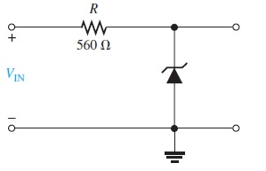

1N4736A

1. Calculate Zener Impedance of this diode if zener current changes to 15 mA from IZK. The ∆VZ is 100 mV. (2)
2. If this diode has negative temperature coefficient of 0.05% /⁰C. Then what is VZ if temperature goes to 50⁰ C. (5)

